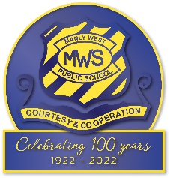

Special Religious Education and Special Education in Ethics Participation Letter

A feature of the public education system in NSW is the opportunity to provide time in class for education in ethics, faith and morality from a religious or non-religious perspective at the choice of parents/carers.

The school website (insert link) provides information on these options to support parent/carer choice. A parent/carer may at any time notify the school in writing that they wish to change their decision .

Students will continue the same arrangement as the previous year, unless a parent/carer has

requested a change in writing.

If your preferred Special Religious Education or Special Education in Ethics option is not available please contact the approved provider. Students not attending Special Religious Education or Special Education in Ethics are given supervised alternative meaningful activities.

For more information about Special Religious Education and Special Education in Ethics, including the list of approved providers, please visit: https://education.nsw.gov.au/religion-and-ethics

The following options are available at (insert name of school). Please choose one.

# Special Religious Education Options

* Option 1:
* Option 2:
* Option 3:

# If you do not wish for your child to attend Special Religious Education, please select below

* Special Education in Ethics (This option to be deleted in schools where SEE is not delivered)
* Alternative meaningful activities.

Student name: Year:

Name of parent/carer: Date:

Signature of parent/carer:

If you selected Special Religious Education or Special Education in Ethics, you confirm that, in doing so, you consent to the

Department providing your child’s name to the nominated approved provider. The Department is required to obtain your consent under section 26 of the Privacy and Personal Information Protection Act 1998 (NSW) so that it does not have to comply with section 19, which would otherwise apply to prevent the Department from providing your child’s name.